Association Rules

- Business Problem
  - What is the business objective?
  - Are there any constraints?
- Work on each feature of the dataset to create a data dictionary as displayed in the below image:
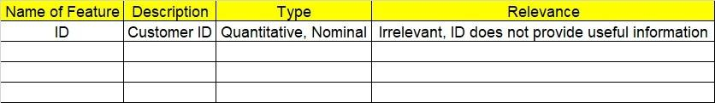

- Data Pre-processing
  - Data Cleaning, Feature Engineering, etc.
- Model Building
4.1 Application of Apriori Algorithm
  - Build most frequent item sets and plot the rules
  - Work on Codes
5.Deployment
5.1 Deploy solutions
6. Write about the benefits/impact of the solution - in what way does the business (client) benefit from the solution provided?

Problem Statement: -
Kitabi Duniya, a famous book store in India, which was established before Independence, the growth of the company was incremental year by year, but due to online selling of books and wide spread Internet access its annual growth started to collapse, seeing sharp downfalls, you as a Data Scientist help this heritage book store gain its popularity back and increase footfall of customers and provide ways the business can improve exponentially, apply Association RuleAlgorithm, explain the rules, and visualize the graphs for clear understanding of solution.
1.) Books.csv

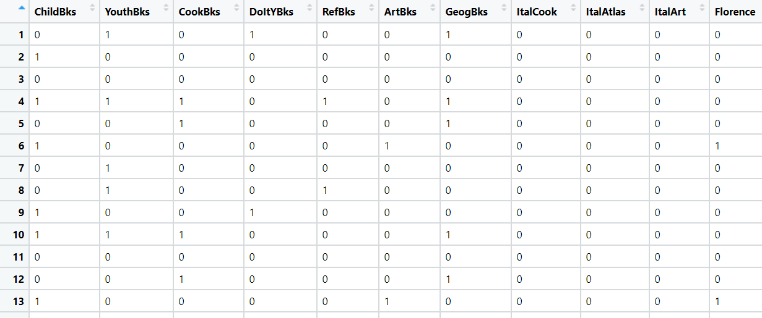
Problem Statement: -
The Departmental Store, has gathered the data of the products it sells on a Daily basis.
Using Association Rules concepts, provide the insights on the rules and the plots.
2.) Groceries.csv
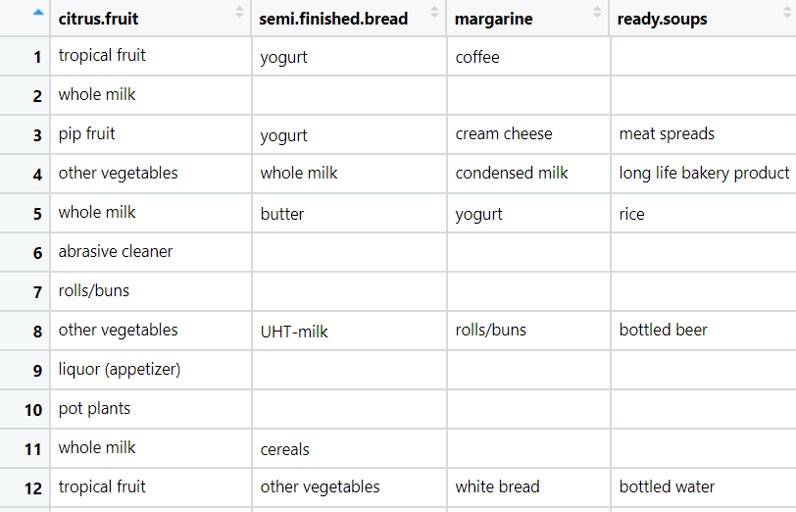

Problem Statement: -
A film distribution company wants to target audience based on their likes and dislikes, you as a Chief Data Scientist Analyze the data and come up with different rules of movie list so that the business objective is achieved.
3.) my_movies.csv
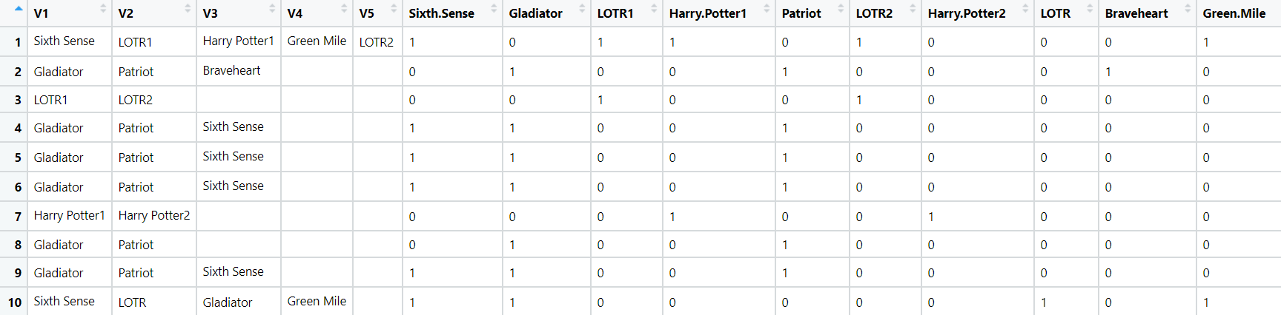

Problem Statement: -
A Mobile Phone manufacturing company wants to launch its three brand new phone into the market, but before going with its traditional marketing approach this time it want to analyze the data of its previous model sales in different regions and you have been hired as an Data Scientist to help them out, use the Association rules concept and provide your insights to the company’s marketing team to improve its sales.
4.) myphonedata.csv

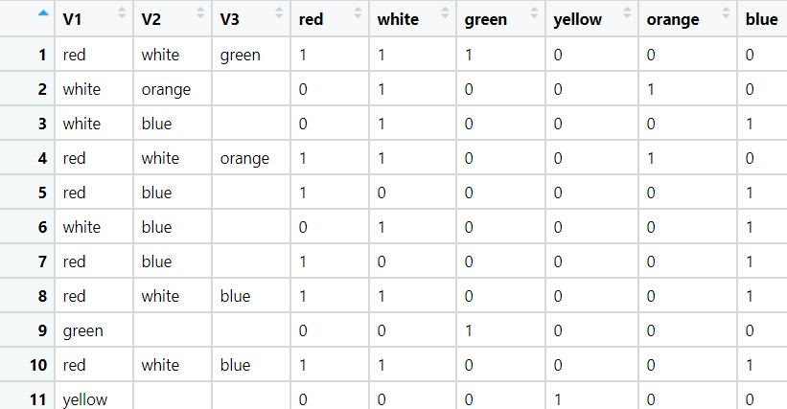
Problem Statement: -
A retail store in India, has its transaction data, and it would like to know the buying pattern of the
consumers in its locality, you have been assigned this task to provide the manager with rules
on how the placement of products needs to be there in shelves so that it can improve the buying
patterns of consumes and increase customer footfall.
5.) transaction_retail.csv

